**User Manual**

**Step 1:** Write your assembly code

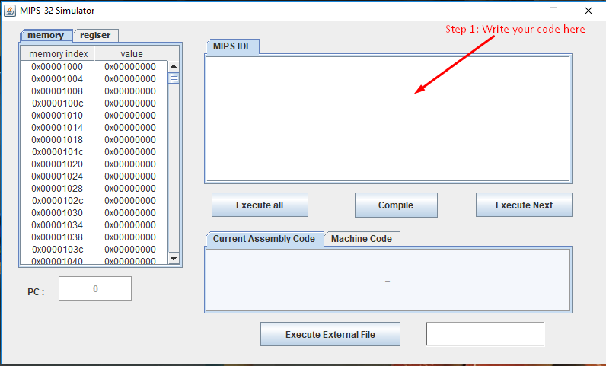

**Note:** if there is any error this message box will pop up after you compile your code.

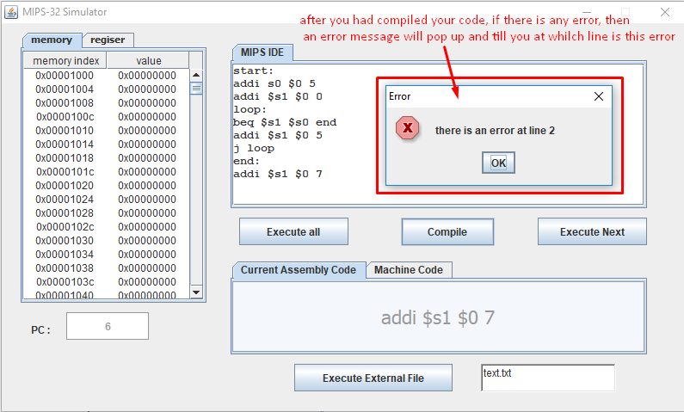

**Step 2:** Click on Compile button to check if there is any error in the written code

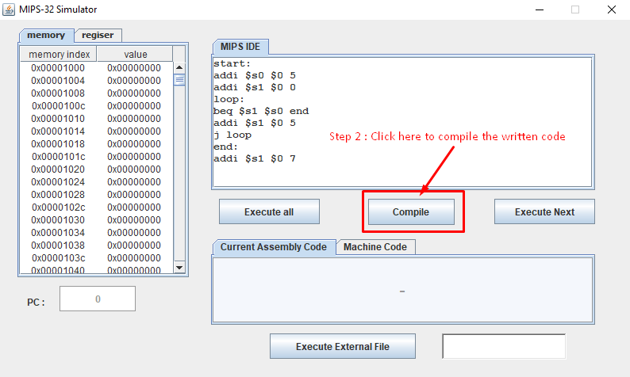

**Step 3:** Click on “Execute all” or “Execute Next” to start your program code

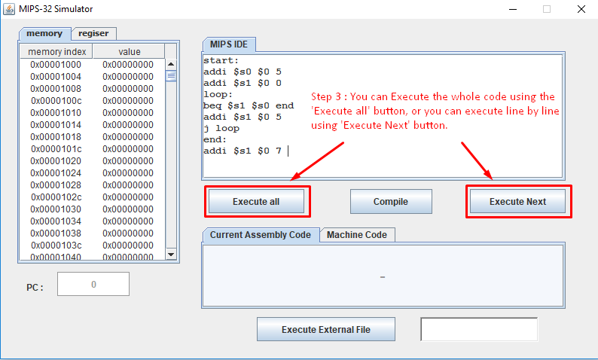

**Note:** You can see if the code run correctly and assign right values in the registers and memory using “memory” and “register” tables

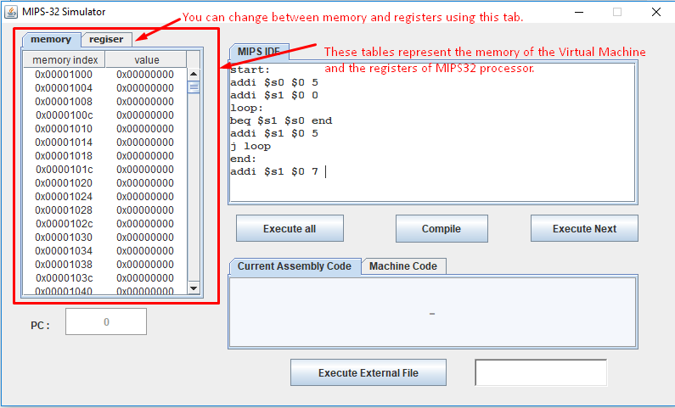

**Note:** You can track the running code using the “Current Assembly Code” tab and “PC” counter that are updated after any execution occurs

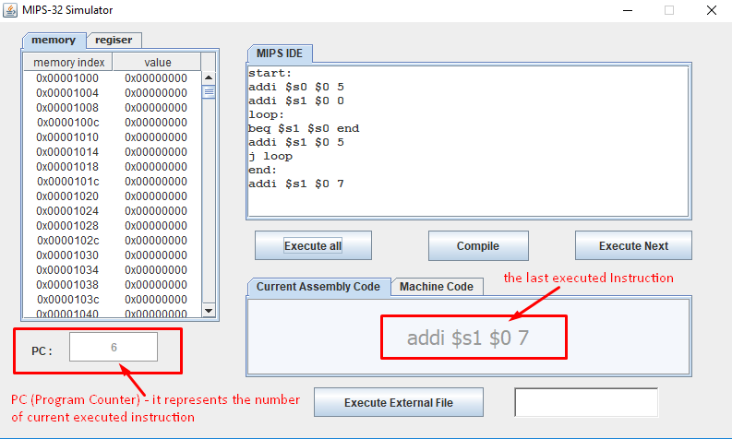

**Note:** if you need to see the translated Machine instruction to the current executed assembly instruction you will find it in “Machine Code” tab.

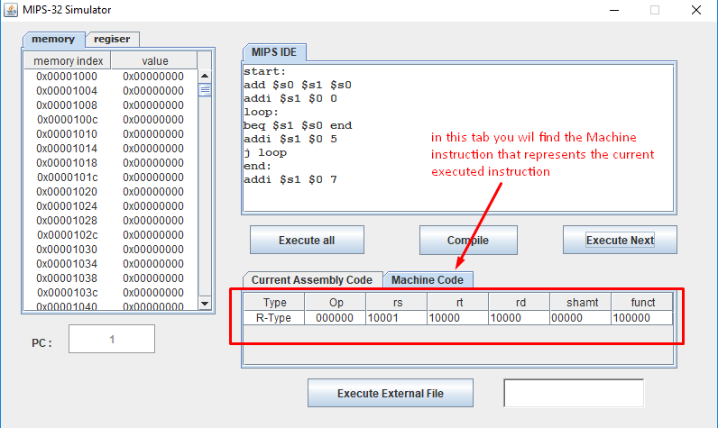

**Note:** if you need to compile and execute an assembly file, use the “Execute External File” button after writing an existing file Name.

